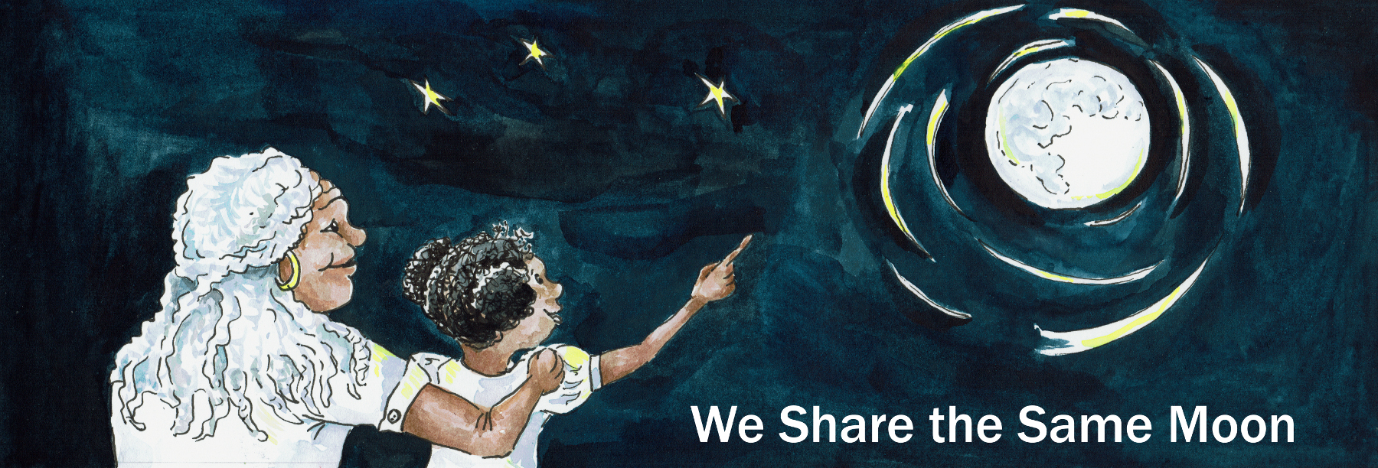
Suggested Age Range: 3 - 4 years: 4 - 5 years; 5 - 6 years; 6 - 7 years
Suggested UK Year Group: EYFS Nursery: EYFS Reception; Year One, Year Two
UK Curriculum: EYFS; Key Stage One;
UK EYFS Curriculum Link: Understanding the World
UK Primary Curriculum Link: Everyday Materials
Science Subject: The Sun, the Sky, the Moon, the Earth
Science Question: What do we see in the Sky?
Suggested Science Activity: Solar System Touch Boxes
Children with SEND: Use to boost comprehension of Maths and Science concepts
EAL children: Beginners level
Country of Origin: Dominican Republic
Source: Folklore from the Dominican Republic by Manuel Andrade.
Contributed by Mij Byram, USA

Long ago, on an island in the Caribbean sea …
There lived a King, in a magnificent palace that was built by the sea, so that he could sit at night on his throne and look out to sea.
And the King sat and looked every night, and he noticed something very strange.
The Moon in the sky, seemed to change shape
Every night, it looked different! How could this be?
He noticed that some nights - it was shaped like a banana.
And other nights - it was shaped like a feather.
Some nights - it was big and round and full!
And other nights - it wasn’t there at all!
How could the Moon change shape? He didn’t know!
So, he called together all of his advisers and said: “Why does the Moon change shape?”
His advisors looked at one another, at the King and then down at the ground.
“We don’t know” they said.
“You don’t know!” said the King! “But your job is to know! That is why you are called “Advisors!” So advise me! Why does the Moon change shape?"
Now, none of them wanted to lose their job so onne of them put up his hand!
“Sire, I know!” “I think it because of a silver bird! She brings silver twigs to build a nest on the Moon - which makes it bigger. As the eggs hatch and the baby birds fly away, the nest falls apart and so the Moon gets smaller!”
“Really?” “Yes sire!” “Is this true?” “Oh yes, sire!”
The King glared at him! "Are you SURE that this is true?”
“Er no! But it is a good story!”
“Anybody else got an idea?”
“ I think it is dragons sire, that eat the Moon and make it smaller!”
“ I think it is magic sire”
They all come up with an idea - but were any of their ideas true? Or just a good story!
The King grew cross!
“This is not good enough! We must go to the Moon and find out!”
We will build a ladder to the Moon!
“Build a ladder to the Moon, sire, but how?”
The King fetched his beautiful box of treasure that was made of wood.
He placed it on the ground. He stood on it.
He was nearer to the Moon - but not near enough to touch it!
“Bring me your boxes” And so they did.
They piled them all up to make a ladder to the Moon!
1, 2, 3, 4, 5 ,6, 7, 8, 9, 10!
And they climbed up to the top box - but were still not close enough!
“Servants!” cried the King “Bring me your boxes”
And so they did. They piled them up to make a bigger ladder to the Moon.
10, 20, 30, 40, 50, 60, 70, 80, 90, 100!
And they climbed up to the top box - but they were still not close enough!
The King ordered everyone living the island to bring their boxes.
They piled them all up to make an even bigger ladder to the Moon!
100, 200, 300, 400, 500, 600, 700, 800, 900, 1000!
And they climbed up and up and up to the top of the ladder of boxes.
And they were almost within reach of the Moon - but not quite!
“Bring me one more box!” cried the King
Sire - there are no more boxes!” said one of his advisors at the bottom of the ladder.
“Then take one box from the bottom of the ladder and pass it up to me!”
“But sire…”“Do as you are told!” “But sire!”“Do as you are told - or else!”
The man shrugged and did as he was told!
And as he pulled the bottom box from the pile…
What do you think happened to the ladder of boxes? Yes you are right - it fell down!
And the King tumbled and twisted and fell with a BUMP to the ground.
And the King never did discover why the Moon changed shape!
But what do YOU think is true?
Is a dragon or a bird or magic that makes the Moon change shape?
Scientists say the Moon doesn’t really change shape,
but what we see of the Moon, that is different every night.
But what do YOU think is true?

Copyright Cassandra Wye, May 2019

